**EXP NO: 18**

**ROTATE LEFT OPERATION**

**AIM:** To compute rotation of given data in left without carry using 8085 processor.

**ALGORITHM:**

1. Load the base address of the array in HL register pair.
2. Move the data from memory location into accumulator.
3. Shift left the accumulator content for four times.
4. Store the result in the specified location.

**PROGRAM:**

MVI A,02

RLC

RLC

RLC

RLC

STA 2000

HLT

**OUTPUT:**

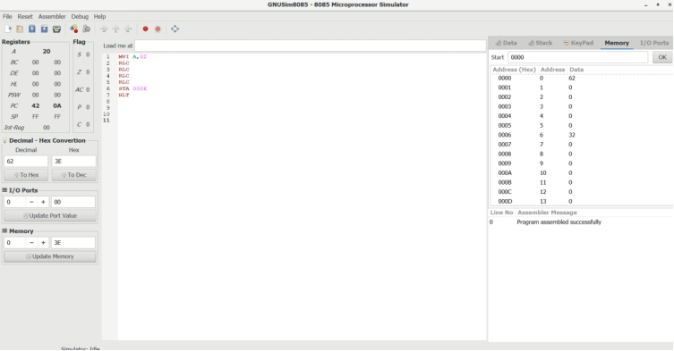

**RESULT:** Thus the program was executed successfully using 8085 processor simulator.